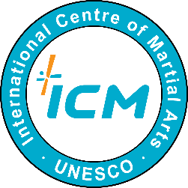 | The 4th International Youth Online Martial Arts Camp  Application Form
Personal Information
Name | Last |  |  |  | First
Gender | □ Male □ Female |  |  | Date of Birth |  | dd/mm/yy
Nationality |  |  |  | Affiliation (School)
Address
E-mail |  |  |  | T-shirt Size |  | □ M □ L □ XL
Telephone |  |  |  | Emergency  Contacts |  | Name / Phone number
English Level
Reading |  | Listening |  | Writing |  | Speaking
□ Basic  □ Intermediate  □ Advanced |  | □ Basic  □ Intermediate  □ Advanced |  | □ Basic  □ Intermediate  □ Advanced |  | □ Basic  □ Intermediate  □ Advanced
Self-introduction and Purpose of Application (10pt, within 300 words)
Consent to Collection and Use of Personal Information
Keeping your personal information safe is one of our top priorities. If you agree with the followings, UNESCO ICM will collect and use your personal information for the camp admission and operation procedure only.
- Items to be collected and used: Information filled out above
- Purpose of collection and use: Admission, Announcement, Operation of Camp

Do you consent to us collecting and using your personal information?
□ Yes □ No

. . 21. (dd/mm/yy)
Name: _____________
Signature: _____________

To the Secretary General of UNESCO ICM

